

|  |
| --- |
| **MATHEMATICS DEPARTMENT 2015**  **Year 11 Specialist - Test Number 2**  **Mathematical Proofs and Counting Methods** |

**Name: _______________________________ Teacher: __________________**

**Marks: 43**

**Time Allowed: 45 minutes**

**Instructions:** You arepermitted your calculator but no notes.

_________________________________________________________________________

Part A

8 multiple-choice questions

1 mark each: 8 marks

Circle the correct answer.

1 Which of the following is a counter-example to the argument below?

If a > b then 

A a = 4, b = 3

B a = 1, b = 

C a = 10, b = 0.1

D a = −2, b = −3

E a = 3, b = −3

[1 mark]

2 The inverse of P symb3 Q is:

A P symb2 Q

B Q  P

C Q symb3 P

D symb4 P symb3 symb4 Q

E symb4 Q symb3 symb4 P

[1 mark]

3 Which of the following is the contrapositive of the statement below?

If sport stars are paid more then they play better.

A If sport stars play better then they are paid more.

B If sport stars do not play better then they are not paid more.

C If sport stars are not paid more then they do not play better.

D If sport stars are paid more then they do not play better.

E If sport stars play better then they are not paid more.

[1 mark]

4 Which of the statements is the correct translation of the following?

For all real x there exists a positive real number y

A ∀ x ∈ N, ∃ y > 0

B ∀ x ∈ R, ∃ y ∈ R: y > 0.

C ∀ x ∈ Q, ∀ y ∈ R, y > 0

D ∀ x ∈ R, ∀ y > 0, y ∈ R

E ∃ x ∈ R, ∃ y ∈ R, y > 0

[1 mark]

5 How many 4 letter ‘words’ can be made from the word EQUALS if Q must be followed by U, and you cannot have QU last?

A 360

B 144

C 156

D 180

E 240

[1 mark]

6 How many students must be taken at random from a class to be sure of getting two with birthdays in the   
same month?

A 7

B 12

C 13

D 366

E 6

[1 mark]

7 How many different anagrams of the word PARALLEL are there?

A 40 320

B 336

C 6720

D 120

E 3360

[1 mark]

8 In how many different ways can 6 different people be arranged in a circle?

A 120

B 720

C 360

D 60

E 1440

[1 mark]

Part B

8 short answer questions

24 marks

Show your working where appropriate.

9 a Write the converse of the statement:

If you are a bilby then you are endangered.

b Decide whether or not the statements are an equivalence. Justify your answer.

[3 marks]

10 Find a counter-example for this statement:

If x2 > 16 then x > 4.

[1 mark]

11 a Prove ΔABC ||| ΔEDC.

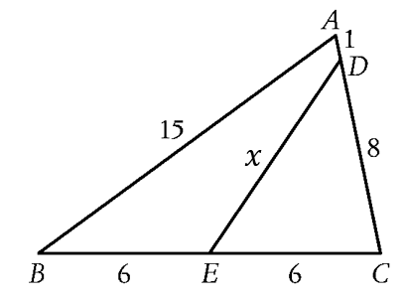

b Hence find the value of .

[4 marks]

12 Consider the contrapositive statement:

If you do not eat cane toads then you do not get sick.

a Write the original statement.

b Decide whether the statement and its contrapositive are true. Justify your answer.

[3 marks]

13 In the diagram, PQ || RS and TQ bisects ∠PQS and TS bisects ∠RSQ.

Prove that ∠QTS = 90.

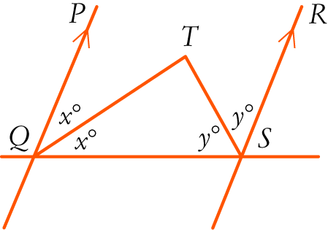

[4 marks]

14 Kate has 6 different tops, 5 different skirts and 3 pairs of sandals. How many different outfits can she make by choosing one of each?

[1 mark]

15 How many 4 letter ‘words’ can be made from the letters of MALTED if the second or third letter must be   
a vowel? Words with two vowels are permitted, but no letters are to be repeated.

[4 marks]

16 A queue for rock concert tickets has 3 couples, 4 people on their own and a group of 3 friends together in a single line. In how many different ways could they be lined up? *(Obviously assume each couple stands together as a couple and the 3 friends stand together.)*

[4 marks]

Part C

3 analysis questions

11 marks

Show your working where appropriate.

17 A large circular table at a restaurant has 9 people from an office seated at random around it.   
What is the probability of Mary being seated between David and Peter?

[3 marks]

18 Decide whether this argument is valid or invalid. Give reasons for your answer.

If you speed on the road then you are an idiot.

I am an idiot.

Therefore I speed on the road.

[2 marks]

19 **Using vectors,** prove that in a triangle, if a line is drawn from a point that divides one side in a given ratio, parallel to a second side, then it divides the third side in the same ratio.

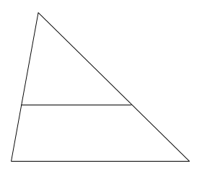

[6 marks]

End of test